Assessment of In-service Science Teachers’ Teaching Competencies in Integrated STEM Program
Tepporn Lomarak¹ Bancha Nuansai² Worrawat Promden³ and Arunrassame Sangsila⁴

¹ Head of General Science Program, Faculty of Education, Buriram Rajabhat University, TH
² Associate director of Research and Development Institute, Buriram Rajabhat University, TH
^{3,4} Lecturrer at General Science Program, Faculty of Education, Buriram Rajabhat University,
TH

E-mail: tlomarak@gmail.com
Abstract. The purpose of the study was to investigate the effects of a professional development instructional program Integrated STEM for elementary schools in a rural context of Thailand which carried out at the Faculty of Education, Buriram Rajabhat University during February 2018. Research instruments were (1) assessment observational record consisted of 5 elements of competencies with 4 levels of rubric criteria including beginning, approaching proficient, proficient, and distinguished levels, (2) achievement test related STEM designed to assess specific science content knowledge. The research findings revealed that the integrated STEM program was recommended to use for developing in-service science teachers’ teaching competencies. From evaluation of experts, the results indicated that competencies’ levels of teaching of in-service science teachers was achieved as approaching proficient level. Moreover, the results of one sample t-test indicated that teachers' achievement score on science content knowledge after implementing the integrated STEM program was significantly higher than before at the 0.01 level. It can be suggested that in-service training programs should be developed and used for science teachers to raise their awareness of the necessity of STEM education and to enhance their competencies in teaching preparation program.
Keywords: Integrated STEM Program, Teaching Competency, STEM instruction, Professional Development Program

1. Introduction
Ministry of Education launched project to engage in-service teachers with innovative classroom. The Institute for the Promotion of Teaching Science and Technology (IPST) has initiated a new approach by emphasizing knowledge and skills which are suitable to professional life in a highly competitive society. STEM education is an integrated approach which stands for science, technology, engineering, and mathematics. These disciplines are distinction in our daily lives, helps us to solve the problem by creative thinking based on contents clarification. STEM education is now distributing around the world, and also in Thailand education. IPST engages STEM education to science and mathematics curriculum, initially introduced with learning activities, and propagating STEM to school practices at national level. To prepare students, the IPST promotes the science process skills, mathematical skills and other skills for the 21st century among learners by way of the integrated science, technology, engineering, and mathematics curriculum. IPST settled STEM education into curriculum and educational policy in 2013. After some seminars, workshops and experimental activities with many countries, the IPST executive committee decided to initiate a campaign to promote integrated STEM teaching and learning in Thai K-12 schools under “the Development and Promotion of STEM Education Project” [1]. Consequently, there could be many unforeseen challenges facing researchers and teachers who are involved in implementing this campaign. It was thought that the investigation of the opinions and suggestions from the teachers and educators who have used STEM strategies might reveal some implications that could lead to effective approach in adoption of STEM instructional practices nationwide and promoting STEM education experiences to increase student engagement and achievement.

Many different instructional practices and STEM approaches have been developed over the years, the lecture-based classroom is still a main delivery method that Thai teachers use to disseminate knowledge. However, teaching competencies such as critical thinking, interpersonal skills and intrapersonal skills are developed not only through obtaining knowledge but also through experience. In this regard, in-service science teachers need to provide an environment in which students take active roles in learning. Regional study on transversal competencies in education policy and practice conducted in Thailand revealed that teachers employed mainly lecture-based approaches, and rarely incorporated student-student interaction. This was the case across all of the subjects observed (mathematics, Thai, English, art and Thai culture) despite policy-level documents in Thailand (both national and school-based) emphasizing the importance of ‘life skills’ and student interaction [2].

There are many benefits that could improve the current situation of science, mathematics and technology education. For example, there are studies showing that learning science through STEM education could result in significant learning gains in science content [4-8]. Also, some studies have shown that students who learn scientific concepts through authentic engineering design process attained significantly higher achievement, more engaging experience and higher knowledge retention than those who learn through scripted inquiry-based teaching methods, especially for students who are underrepresented groups such as Black and Hispanic [9-10]. Moreover, it has shown that exposure to STEM activities positively impacts elementary students' perceptions and dispositions [11]. So that, programs focusing on integrated STEM approaches should a growing priority in elementary schools with aims to provide early exposure for students, especially in rural areas of Thailand.

Professional development has a significant role in preparing in-service science teachers with adequate instructional practices and promoting STEM education experiences. However, the current teaching practices in Thailand do not often respond to the needs of STEM learning environments, such as inquiry and student-centered approaches and the utilizing of integrated STEM curriculum in rural context of Thailand. These, in turn, require in-service science teacher to have skills for collaboration and ability of using STEM strategies for organizing and delivering instruction through integrating technology and engineering into science and mathematics. Although, IPST promotes concepts and some activities through national workshop, online-based training, and face to face by STEM experts and STEM core trainers nationwide. STEM education is less monitoring the need for supporting and assessing competencies’ levels of teaching and evaluating specific content knowledge related STEM instruction to enhance in-service science teachers’ competencies in rural context of Thailand. In addition, there is a lack of research on the effects of a professional development program integrated STEM for elementary schools in a rural context of Thailand. Based on the current situation, we have identified the main challenges in assessing need for supporting and building competencies’ levels of teaching and evaluating specific content knowledge related STEM instruction to enhance in-service science teachers’ competencies in rural context of Thailand.

2.Objectives
The aims of this research were:
(1) To assess teachers’ competencies of teaching after participating integrated STEM workshop.
(2) To examine the effect of the integrated STEM program by assessing teachers' achievement score on science content knowledge after implementing the integrated STEM workshop.

3. Method
3.1 Research Design
In this study, we used qualitative research to examine competencies’ levels of teaching STEM activity by using assessment observational rubric consisted of 5 elements of competencies with 4 levels of rubric criteria including beginning, approaching proficient, proficient, and distinguished levels. We developed and applied the STEM achievement test items which comprises multiple choice and short answer response achievement test items designed to assess specific science content knowledge regarding STEM activity. The One Sample t-test was employed to examine the effect of using the integrated STEM program.

3.2 Participants
The participants in this study included 30 teachers from STEM workshops of Research and Academic Services organized by Faculty of Education, Buriram Rajabhat University. Participant teachers came from public schools located near the Thai-Cambodian borders, and included 24 primary and 6 lower secondary teachers aged between 26 and 52 years old. In-service elementary science teachers (N = 30) were enrolled in the STEM workshops during 17-18 February 2018. These teachers are having 3 to 20 years of experience in elementary school level but they were usually not taught STEM as part of a normal curriculum before. All of these teachers had a bachelor degree and were assigned to teach more than one subject and more than one grade level.

3.3 Design of the STEM Workshop
The STEM workshop consisted of four activities lasting about two hours and 30 minutes each. Four areas were identified for the development of workshops. The areas were: (1) exploring STEM concepts, which was principally concepts, methodologies, tools, and applications; (2) engineering design process, which was a mindset that emphasizes open-ended problem solving and encourages learners to learn from failure; (3) good design, materials, and construction, which was principally preparation and testing of structures; (4) simple machines, as incorporated into the “Chain Reaction in Marble Run Activity (Figure 1).”

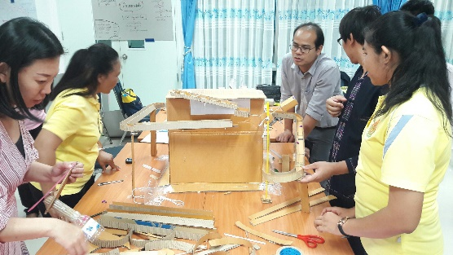  Figure 1. Simple machines, as incorporated into the “Chain Reaction in Marble Run Activity | 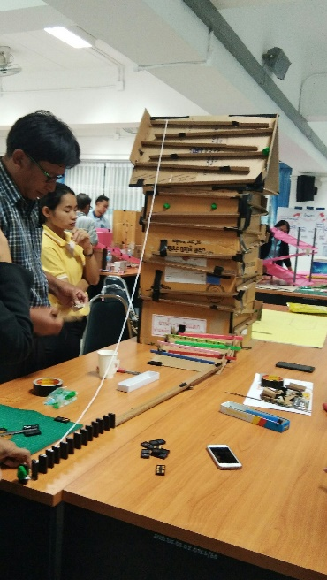  Figure 2. Utilizing the engineering design process to design, build, and test their creations of the prototype
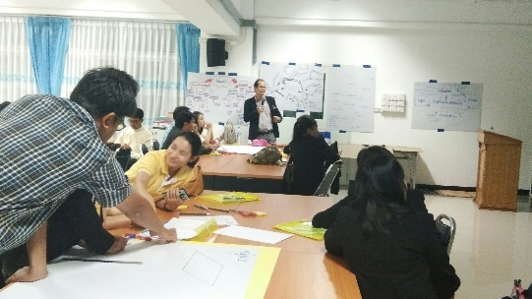
Figure 3. Facilitator asking the higher-order thinking questions during STEM workshop

The integrated STEM workshop lasting for 2 days (organized during 17-18 February 2018) was designed with a focus on encouraging rural in-service science teachers to solve an ill-defined problem utilizing the engineering design process to design, build, and test their creations of a chain reaction in marble run (see Figure 2). In the challenge situation, teachers would be asked to consider the constraints of the materials and time, identify the problem, think about what they already know, design, plan, construct, test and evaluate a physical prototype of their track design. Teachers were encouraged to construct a convincing argument for a particular solution as opposed to all other possible solutions and start out by drawing plan of their prototype with dimensions and details on a chart paper provided. Each team consisted of 4-5 science teachers and received only 2 plastic tubes, 2 paper boxes, 30 pieces of dominoes, 1 plastic board, 1 pair of scissors, 1 roll clear sticky tape, 1 roll cotton rope and at least 1 marble. Researchers gave teams 20 minutes to plan their marble run track and give teams 30 minutes to build their marble run. They ask to create a track that keeps a marble rolling as long as possible (longer than 3 minutes). The 2 days STEM workshop consisted of integrated STEM activities lasting about 12 hours. Teachers also needed to answer the higher-order thinking questions during participating STEM activities (see Figure 3). In particularly, answering the questions inspired teachers to acquire new knowledge, competences and 21st century skills in group working. Some samples of questions used were: “In your opinion, if your tracks were constructed identical to this prototype, how to keep children safe while they are on? If yes/no, please explain why?” (Evaluation of cause-effect relationship based on science concepts); and “How can your prototype be modified in order to improve its results in the future?” (Analysis of experimental design). The questions were specially designed to evaluate teachers’ analysis, critical thinking, evaluation and communication skills in connecting STEM activities with their daily life. Finally, in-service science teachers took the achievement test on science content knowledge after implementing the integrated STEM workshop.

3.4 Instruments
Research instruments were: (1) Assessment observational record used to assess teaching competencies adapted from Charlotte Danielson' framework for teaching evaluation instrument, 2013 edition [12]; (2) Multiple choice and short answer response test items designed to assess specific science content knowledge about STEM activity. The achievement test on science content knowledge related STEM (ATSCK-STEM) consisted of 43 multiple choice test items and 31 short answer response test items with 80 total score. The ATSCK-STEM was verified by three experts to find the Index of Item Objective Congruence between test items and learning objectives. The IOC was found to be 0.67-1.00. The reliability of the ATSCK measured by Cronbach alpha was 0.895. Discrimination indices ranged from 0.33-0.46. Difficulty indices ranged from 0.31 to 0.80 providing a wide range of difficulty in the items.

3.5 Data Collection
Items for the assessment observational record were developed and adapted from Charlotte Danielson' framework for teaching evaluation instrument, 2013 Edition. All criteria were later reviewed and validated by a group of 12 experienced science teachers and 3 university professors to give comment on the readability and coherent of the criteria in the assessment observational record before being adopted as research instruments. These experts agreed that all items were relevant and should remain in the study. After participating the STEM workshop, teachers have a responsibility to plan and manage their own STEM activities and practices in their classrooms. Researchers and experts followed up teachers to assess teaching competencies focused on the role of the teacher in the classroom, directly linked with the craft of teaching – with professional knowledge and skills for action in their classroom. The assessment observational record consisted of 5 elements of competencies with 4 levels of rubric criteria including beginning, approaching proficient, proficient, and distinguished levels.

The assessment observational record utilizing for data collection after implementing the STEM workshop, included 4 parts:
Part 1: asked about the background information of the participants (e.g., age, education background, teaching experience).
Part 2: asked about teachers’ prior experiences, understanding of content knowledge regarding STEM activities and approaches. Researchers employed a multiple choice and short answer response test items designed to assess specific science content knowledge about STEM activity.
Part 3: in-service teachers selected their preference from seven steps of engineering design process (see Figure 4) represented by a diagram with brief description as following to create STEM activity for teaching in their classroom after participating the STEM workshop.
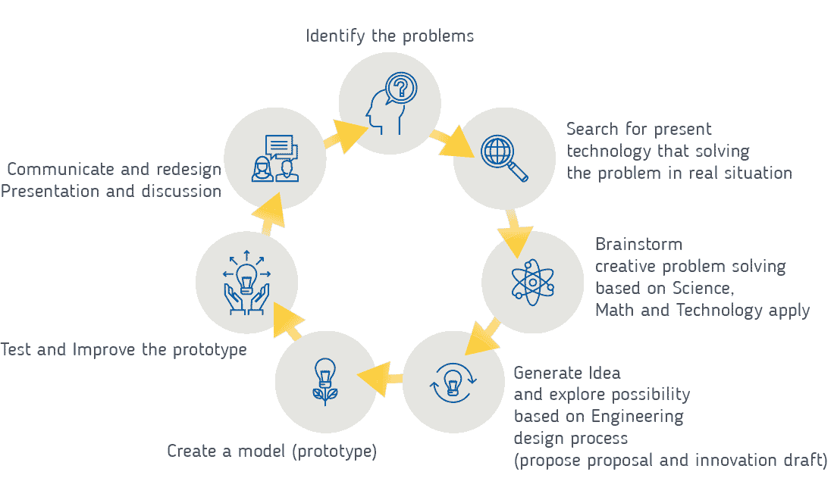
Figure 4. The seven steps of engineering design process

Part 4: the assessment observational record form consisted of 5 domains of competencies with 4 levels of rubric criteria including beginning, approaching proficient, proficient, and distinguished levels.
The use of coaching and mentoring approaches for deliberated school improvement involve both conversations and classroom observations. These approaches provide opportunities for in-school professional learning and support classroom walk through, by focusing on specific theme or topics.
Then, this process is particularly to support the achievement of teaching practice and competencies of STEM approach. For assessing teaching competencies’ level and performance, these processes were employed: (1) pre-observation meeting was to typically focus on the type of specific lesson being planned and aspects or criteria the teacher would like the observer to focus on; (2) classroom observations were intended to provide direct feedback on the specific pedagogies used by teachers in situ. The criteria and indicators an observer might use were outlined as followings: planning and preparation of STEM approach, classroom environment and management, instruction strategies, assessment in instruction and reflecting on teaching and feedback.

3.6 Data Analysis
In this research study, the effect of implementing the integrated STEM program was examined by using the ATSCK-STEM consisted of 43 multiple choice test items and 31 short answer response test items. Data was analyzed to examine the effect of the integrated STEM program by assessing teachers' achievement score on science content knowledge after implementing the integrated STEM workshop. The finding was used to justify whether in-service science teachers had a satisfactory achievement with respect to an established criterion at 75 % of total score (total score = 80).
Comparison of the in-service science teachers’ achievement after implementing the integrated STEM program was performed statistically by using the one sample t-test to examine whether difference in achievement score exists.

Responses from the interviews, document, lesson plans and information on classroom observations were explored to assessing teachers’ competencies after participating integrated STEM workshop. Coaching and mentoring approaches were use as the process of following up for deliberated teacher’s improvement involve both conversations with teachers and classroom observations. After pre-observation meeting with school director and science teachers, classroom observations were organized to provide feedback on the specific pedagogies used by teachers. Assessment observational record were used as instrument to evaluate teaching competencies of in-service science teachers.

4. Results and Discussion
4.1 Teachers’ competencies after participating STEM workshop followed by meetings during the academic year
Researchers followed up in-service science teachers lasting 8 weeks began on May 1st, 2018 and continues through June 22nd, 2018 by using coaching and mentoring approach for involving meeting, group discussion with conversations and classroom observations. By focusing on assessing teaching competencies’ level and performance of in-service science teachers, classroom observations were intended to provide feedback on the specific pedagogies used by teachers on-the-job training. As shown in table 1, the results revealed that the level of teaching skills among the in-service science teachers is approaching proficient level in all essential elements of teaching competencies.

Table 1. Teaching competencies’ level of in-service science teachers (N=30)
Elements of competencies | Mean | S.D.
1. planning for STEM instruction | 2.10 | 0.33
2. classroom environment and learning management | 2.67 | 0.48
3. strategies for encouraging student to learn effectively | 2.63 | 0.24
4. feedback and assessment | 2.45 | 0.34
5. teaching reflection | 2.49 | 0.40
Average | 2.48 | 0.41

From experts’ evaluation, the results indicated that competencies’ levels of teaching and pedagogical content knowledge (PCK) of in-service science teachers was achieved as approaching proficient level (Mean = 2.48, S.D.=0.41) in five elements of competencies.

The results revealed, as shown in table 1, the level of teaching skills among the in-service science teachers was not achieved proficient level. It can be noted that there are common characteristics and content that unite the STEM activities, especially in science and technology, which establishes the need for collaboration and ways for these teachers to work together within schools. In-service science teachers who participating in long professional development program on STEM integration and felt that they also needed to work together with other teachers in other STEM disciplines because they only familiar to teach mathematics not STEM activity [13]. Given severe time constraints for evaluating teaching competencies in schools due to teacher workload [14], management lesson plan in schools will need to consider the creation of sufficient time to allow the collaboration to undertake their role during informal meeting, organizing lesson plan and classroom observing. This may be particularly problematic in some elementary where teachers were already engaged in full-time in-service duty. It is reasonable to assume that teachers in some schools, in this study, may be reluctant to take on the additional responsibilities inherent in teaching STEM activities according to follow-up process after implementing STEM workshop. Our observational data, classroom observation and assessment of teaching competencies are also not complete as the in-service science teachers may employ only a small part of their accumulation of PCK for teaching STEM and they may need more collaboration undertake the role in teaching STEM activity. In this study, the level of teaching competencies of in-service science teachers is approaching proficient level because PCK might develop along with teaching experience in science [15-17]. It is pointed out that teaching experience is an important factor that affect development of teaching competencies’ level. Providing experience for in-service science teachers to practices with artificial class or micro-teaching will create an opportunity for them to use their theoretical science content knowledge and PCK in classroom environment. In this way, in-service science teachers will catch the chance of gaining experience through teaching STEM activity. Micro-teaching practices for in-service teachers also requires physical environment and technical equipment for preparation STEM lesson. At this point, schools should be provided with essential support.

4.2 Teachers’ achievement score on science content knowledge related STEM
Teachers’ achievement score was assessed by the ATSCK-STEM consisting of 43 multiple choice test items and 31 short answer response test items with 80 total score. The score of ATSCK-STEM were collected and analyzed after STEM workshop. The results of comparison of the post-test score and the criterion score of 75% (Table 2).

Table 2. The comparison of the mean score of in-service science teachers' achievement score and the criterion score

Score | N | Total score | $$\overline{x}$$ | S.D. | % of Mean | t
Posttest | 30 | 80 | 63.23 | 4.569 | 79.04 | 3.88ª
ª t _{(0.01; df =29)} =2.756
The results of t-test one sample indicated that teachers' achievement score on content knowledge related STEM after implementing the integrated STEM program was higher than the criterion score of 75% at the 0.01 level of significance. In this study during implementing STEM workshop, constructivist approaches, problem-based learning, and making connections to the real world often characterized effective STEM activity. In the classroom, constructivist approaches, problem-based learning, and making connections to the real world often characterize effective STEM education when implemented using inquiry-based strategies. Techniques such as active learning and forming cooperative learning groups are central to achieving the most important outcomes of STEM [18]. STEM activities and instructional strategies that were found to be effective include questioning techniques, guided independent research studies, and discussion groups. The results consistent with other research studies in high school level, in adoption of a STEM-focused curriculum, reform instructional strategies, project-based learning, and integrated and innovative technology are in use by independent STEM [19-20]. Elementary schools with successful STEM emphasis demonstrated that improved student learning in science, mathematics and reading shared 5 common elements including professional capacity of colleague and staff, learning communities, a student-centered learning environment, and instructional guidance [21]. In this study, in-service science teachers were provided opportunities to explore STEM concepts, procedures, tools, and applications and experience engineering design process, which was principally preparation and testing of structures, materials, and construction. Workshop planning emphasized open-ended problem solving and encourages in-service science teachers to learn simple and complex machines, as incorporated into the “Marble Run Activity”. The time for doing integrated STEM workshop was designed appropriately for encouraging these teachers to solve an ill-defined problem utilizing the engineering design process to design, build, and test their creations during workshop. These findings suggest that engineering design activities that integrate the STEM components can help students contextualize the principles of science to improve learning achievement [22]. So that, teachers' achievement score on content knowledge related STEM after implementing the integrated STEM program was higher than the criterion score of 75% at the 0.01 level of significance.

5. Recommendation
5.1 Professional development program integrated STEM activities as partnership in school improvement
In-service science teachers suggested that a direct dialogue between teachers and researchers on STEM activities during informal meeting before classroom observation would be essential for promoting STEM initiative program in elementary schools. In-service science teachers suggested that this informal meeting, collaboration after STEM workshops, on-the jobs training at school and classroom observation can occur through a partnership between teachers and researchers. In addition, in-service science teachers recommended that good partnerships can replace the traditional professional development programs and that help teachers and researchers can work together to design and develop lesson plans, curriculum materials and deliver instruction to promoting STEM for elementary students in context of rural areas.

One of the important findings of this study showed that the school culture plays a key role concerning the implementation of STEM at elementary school. The study showed that implementing STEM education in non-STEM schools required a different preparation than that in STEM schools. The non-STEM school culture required collaboration among in-service science teachers and need more building a collaborative and supportive STEM community in school. In this study suggests that exchange of experience and constant dialogue between teachers and the administrators during observing teaching in the school were highly emphasized.

5.2 Recommendations for policy makers
Therefore, researchers can provide recommendations at the policy level to introduce STEM programs for in-service science teachers in rural context. This could lead to developing a STEM partnership-based professional development model of what teachers need in terms of content knowledge related STEM and how to assess PCK to enact STEM education in different school culture and local context.

6. Limitations of the study
This study only focuses on in-service science teachers engaged in STEM teaching in rural areas of Thailand, and therefore it is difficult to generalize. Besides, because of the nature of PCK, it is difficult to identify its components with clear boundaries. Our observational data, document analysis and classroom observation are also not complete as the in-service science teachers may employ only a small part of his/her accumulation of PCK for teaching STEM. Another difficulty is that analyzing teaching competencies is time-consuming to develop, administer, and analyze.

7. Acknowledgement
This research was conducted as part of the professional development program for in-service science teachers organized by General Science Program, Faculty of Education, with financial support from Research and Development Institute, Buriram Rajabhat University and National Research Council of Thailand (Grant number 85/2017).

References
[1] The Institute for the Promotion of Teaching Science and Technology 2013 The Development and
Promotion of STEM Education Project (Bangkok: IPST)
[2] UNESCO 2016 School and Teaching Practices for Twenty-first Century Challenges: Lessons from
the Asia-Pacific Region United Nations Educational, Scientific and Cultural Organization
(UNESCO: Bangkok Office)
[3] Fortus D, Dershimer C, Krajcik J, Marx R and Mamlok-Naaman R 2004 Design-based science
and student learning J. of Res.in Sci. Teach. 41(10) pp 1081-1110
[4] Svarovsky G N and Shaffer D W 2007 Soda constructing knowledge through Exploratoids J. of
Res.in Sci. Teach. 44(1) pp 133–153.
[5] Wendell K B and Lee H S 2010 Elementary students' learning of materials science practices
through instruction based on engineering design tasks J. of Sci.educ.and Sci. Technol. 19(6) pp
580-601
[6] Apedoe X S, Reynolds B, Ellefson M R and Schunn C D 2008 Bringing engineering design into
high school science classrooms: The heating/cooling unit J. of Sci.educ.and Sci. Technol. 17(5) pp
454-465
[7] Riskowski J L, Todd C V, Wee B, Dark M and Harbor J 2009 Exploring the effectiveness of an
interdisciplinary water resources engineering module in an eighth-grade science course
International. J. of Engineer. Educ. 25(1) pp 181-195
[8] Mehalik M. M, Doppelt Y and Schuun C D 2008 Middle-school science through design-based
learning versus scripted inquiry: Better overall science concept learning and equity gap reduction
J. of Engineer. Educ. 97(1) pp 71-85
[9] Cantrell P, Pekcan G, Itani A and Velasquez-Bryant, N 2006 The effect of engineering modules on
student learning in middle school science classroom J. of Engineer. Educ. 95(4) 301
[10] Vasquez J, Sneider C, and Comer M, 2013 STEM Lesson Essentials: Integrating Science,
Technology, Engineering, and Mathematics (Portsmouth, NH: Heinemann)
[11] Bagiati Aikaterini, Yoon So Yoon, Evangelou Demetra and Ngambeki Ida 2010 Engineering
Curricula in Early Education: Describing the Landscape of Open Resources Early. Child. Res.&
Pract.12 (2)
[12] Charlotte Danielson 2013 Framework for Teaching Evaluation Instrument, 2013 (Princeton, NJ:
The Danielson Group)
[13] Wang H, Moore T J, Roehrig G H, Park 2011 STEM Integration: Teacher Perceptions and
Practice. J.of Pre-College. Engineer. Educ.Res. 1(2) pp 1-13
[14] Rhodes C P and Houghton-Hill S 2000 The Linkage of Continuing Professional Development
and the Classroom Experience of Pupils: barriers perceived by senior managers in some
secondary schools J.of In-Service.Educ. 26 pp 423-35
[15] Baxter J A and Lederman N G 1999 Assessment and measurement of pedagogical content
knowledge. In Gess-Newsome J and Lederman N G (Eds.), “Examining pedagogical content
knowledge” (Dordrecht, The Netherlands: Kluwer Academic Publisher) pp 147-161

[16] Magnusson S, Krajacik J and Borko H 1999 Nature, sources, and development of PCK for
science teaching In Gess-Newsome J and Lederman N G (eds.) “Examining PCK: The construct
and its implications for science education” (Boston: Kluwer Academic Press) pp 95-120
[17] van Driel J H, de Jong O and Verloop N 2002 The development of preservice chemistry
teachers’ pedagogical content knowledge Sci. Educ. 86 pp 572-590
[18] Smith K, Douglas T C and Cox M F 2009 Supportive Teaching and Learning Strategies in STEM
Education. Book chapter in New Directions in Teaching and Learning: Creating Culture/Climate
that Supports Undergraduate Teaching and Learning in Science, Technology, Engineering, and
Mathematics 117 pp 19-32
[19] Bruce-Davis M N, Gubbins E J, Gilson C M, Villanueva M, Foreman J L and Rubenstein L D
2014 STEM high school administrators’, teachers’, and students’ perceptions of curricular and
instructional strategies and practices J. of Advance. Academics 25(3) pp 272-306
[20] Lynch S J, Behrend T, Peters Burton E and Means B 2013 Inclusive STEM-focused high
schools: STEM education policy and opportunity structures. Paper Prepared for NARST 2013
Annual Conference.
[21] National Research Council 2011 Successful K-12 STEM Education: Identifying Effective
Approaches in Science, Technology, Engineering, and Mathematics (Washington, DC: The
National Academies Press)
[22] English L 2016 STEM education K-12: perspectives on integration Int. Journal of STEM
Education 3(1)

